How to adapt the Implementation Blueprint at the local level

1
- How to use this tool
The implementation blueprint is designed to be a tool for local health jurisdictions (LHJs) to plan the ways they can most successfully implement changes that advance strategies in the statewide strategic plan to address HIV, HCV, and STIs, while maintaining core public health functions we know work. The document is templated for local customization and is designed to be edited to meet the needs of LHJs. The blueprint should ideally combine existing plans and streamline work, rather than create additional and siloed work.
Below (2) is a big-picture overview of the steps of local Blueprint adaptation, and (3) the next page offers step-by-step guidance for adapting the blueprint to your needs.

2
- Big-picture phases of local Blueprint adaptation
There are three key phases to local Blueprint adaptation. In the (i) initial phase, LHJs focus on developing buy-in and commitment, level setting, and beginning to localize the blueprint. In the (ii) feedback phase, LHJs focus on iterative stakeholder engagement and integration of stakeholder feedback. In the (iii) finalization phase, LHJs focus on getting approvals for the local blueprint and disseminating it.
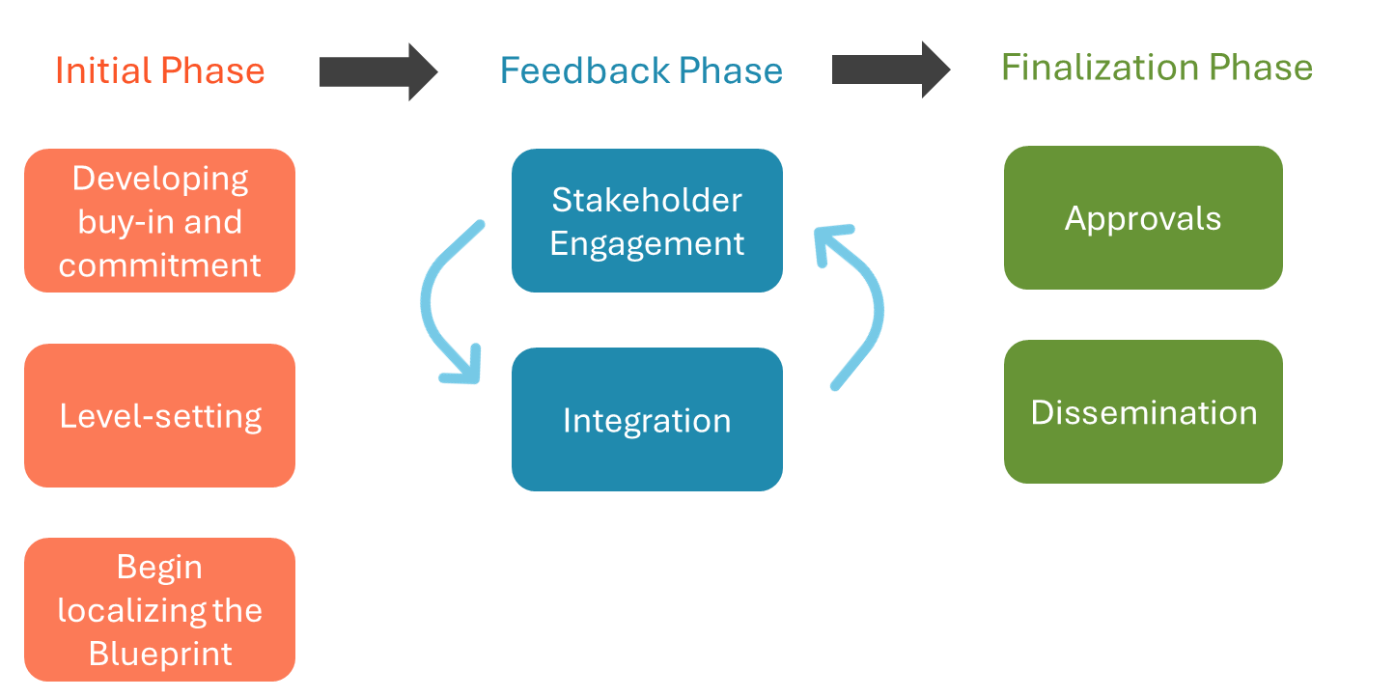

The next section (3) offers more detailed guidance for each phase of local Blueprint adaptation.
- Guidance for local Blueprint adaptation

3
The tables on the next three pages offer key steps, activities, and considerations for each phase (initial, feedback, and finalization) of local Blueprint adaptation. You can add your own notes or local considerations in the column on the right.
(i) Initial Phase
Step | Activity/Task |  | Your notes here
Developing buy-in and commitment | Commit to developing a localized implementation blueprint to guide your LHJ’s work over the next several years.
Level-setting | Gather documents and existing plans, including Getting to Zero, elimination plans, EHE, and/or HIV, STIs, and HCV plans.
 | Review for continued relevance, ensuring existing activities that will continue are reflected and looking to identify gaps that require new/innovative solutions.
Begin Localizing the Blueprint | Remove any activities that are not relevant for your LHJ.
 | Integrate the established activities from your existing documents and plans into the implementation blueprint template.
 | Adapt any of the strategies supplied in the template as needed to reflect what makes most sense for your LHJ.

NOTE: You do not have to do every strategy, please just pick relevant ones.
CONSIDER:
-Who needs to be in the room?
-How can work on HIV, HCV, and STIs be integrated in your LHJ?
(ii) Feedback Phase
Step | Activity/Task | Your notes
Stakeholder Engagement | Meet with internal and external stakeholders to establish buy-in and receive feedback on strategic activities within the drafted local blueprint.
Integration | Integrate feedback from internal and external stakeholders.
 | Develop a revised draft for further review.
Stakeholder Engagement | Provide opportunities for further review. This could be done via presentations, an online public comment period, or formal review if LHJ has a pre-established process for adopting plans.
Integration | Integrate this feedback, as necessary to produce an approval-ready draft.
CONSIDER:
-Set expectations that not all feedback can be incorporated based on funding/ resource limitations and other factors; however, the LHJ will consider and attempt to integrate feedback where feasible.
(iii) Finalization Phase
Step | Activity/Task | Your notes
Approvals | Seek and receive internal approvals.
Finalization | Finalize blueprint.
Dissemination | Announce blueprint internally and externally.
 | Develop a dissemination plan for how you want to communicate this within your LHJ and if you want to publicly share with community (post on your webpage, share in a newsletter, etc).
 | Disseminate the adapted blueprint based on your dissemination plan.

NOTE: LHJs are also encouraged to share their blueprint with CDPH.

